DAO Manual:

Full Outreach and Ongoing Engagement
Move Renee’s Content

Health Data Exploration Project: Personal Data for the Public Good
Robert Wood Johnson Foundation
“…individuals’ willingness to share is dependent on what data is shared, how the data will be used, who will have access to the data and when, what regulations and legal protections are in place, and the level of compensation or benefit (both personal and public).”

Group Projects: Project Focus and Goals
- Internally determine project focus and goals
  - Assign tangible outcomes (ie goal for how many members of your community you want to reach out to and what percent you can enroll in the registry)
- Strengths and Weaknesses
  - Outreach
  - Partners
  - Amongst member community

Understand the community’s perceptions of data sharing

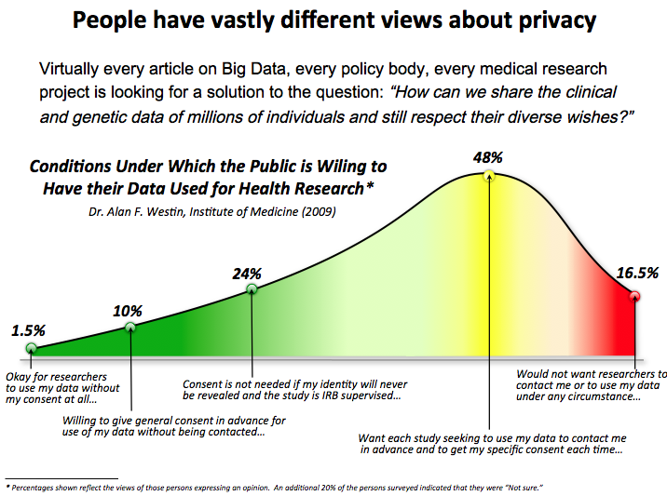

Launch Day:

- Send out a press release (a sample will be provided)
- Post an op-ed piece on a “do it yourself” news page. Some local newspapers have them. Here is an example of one in Colorado: http://www.denverpost.com/yourhub. Here is a list of op-ed information for various newspapers: http://www.theopedproject.org/index.php?option=com_content&view=article&id=47&Itemid=54
- Post your launch information on your Facebook page. If possible, make sure there is a graphic in it to grab attention or link to your survey page so that it will show the image on Facebook.
- Post your launch information/Press Release on Twitter.
- Send a Constant Contact (or other email client) message about the launch to your members.
- Post your launch information in all of your forums, listservs, groups

Post-Launch Continuous Outreach:
Your continued outreach will involve messaging to your members and others on a regular basis through a number of means, depending upon your ability. You will develop a specific plan for your own organization. Below are ideas for outreach to member participants and non-member, potential participants. These are meant to help you to think about what you might do, but is not meant to be directive.

Frequency and reach are important to grabbing the attention of participants.
You will need to spend time on outreach every week for the number of weeks you are trying to get people to take your survey. They need to hear about it from you, your partners, the doctors and clinics you work with, the media, their friends and family, their support group sources, other support organizations and anyone else who can help you to make sure they realize they need to take action.

Outreach to member patients

The following are many different communication methods you can use to reach your own membership. Use as many of them as possible. If possible, assign someone in your organization to be responsible for getting these messages out on a weekly schedule.

Social media, listservs and other groups
- On a Facebook fan page, you can pay to boost posts on others’ feeds
- Post a variety of messages that appeal to different people in different ways

- Post regular updates about your success in getting responses and, if possible, put a thermometer on your website that shows the number of people who have taken the survey against your goal number.
- Not everyone is connected to the Internet, so it may be beneficial to call your members and speak to them directly about your project. This way, if they have any questions you can answer them immediately.

All types of mail:
- Send emails through Constant Contact or other email clients
- Send postcards to your members by regular mail.
- If you use an advocacy alert system, send out a message asking for involvement
- Newsletters

Utilize thought leaders in your membership
- Reach out to specific individuals, asking for their help because they are leaders in your group. Ask them to take the survey and post on your Facebook page or other groups about how easy it was and why it is important. Be sure to ask a variety of people to get involved.
- Ask leaders to speak briefly at your launch party.

Ask members to help
- Many of your members have blogs and Facebook pages chronicling their experience within your community. Reach out to your membership to ask who has such blogs and Facebook pages and ask them to post about your project, and to tag your page in the post.
- Many of your members are also on Twitter. Be sure to ask them to retweet your tweets.
- Ask members to forward your messages to members they know who do not stay connected to your group.
- Create a Youtube about your project and ask your members to share it.
- Ask members to forward your messages about the project to interested communities of which they belong (such as support groups).
- Add a feature on your website so that people can refer their friends after completing the survey.

In-person meetings & Webinars
- The size of your organization will largely dictate your ability to engage with your members face to face.
- Smaller organizations:
  - Bring a laptop or tablet to a meeting and help people to use the survey
- Organizations of any size:
  - Give a conference presentation about the project and why it is important (we have created a Powerpoint presentation for you to use. You can give the presentation at a conference or in a Webinar).
- Conduct a webinar on the project, record it and post it to your Web page

Your organization can conduct events directly related to your project such as:

- Launch party – have an in-person or virtual launch party (or both at the same time). Invite your members and any local partners you may have. Give a short presentation and have some fun as well. Announce your event through a Facebook event so that all of your followers get an invitation or send out formal invitations for an in-person event. You can also do a creative online launch party on Twitter or Facebook.
- SCHEDULE Day - To address some of the concerns everyone has about members not having time to do the survey, schedule an “event” post-launch where you ask your members to SCHEDULE that day to do their survey. On that day, have volunteers from your organization available to answer questions about filling out the survey (navigators). You can obviously do more than one SCHEDULE day.
  - For some of you who have members who will need family or friends to help them to fill out the survey, be sure to mention that they should also schedule a friend or family member for that day to help them.
  - Create buzz around your SCHEDULE day. When you send the invitation on Facebook, they will answer if they will “attend” or not. That will give you some idea of how many people were paying attention. If it is successful, do another one! Even if members don’t participate on that day, you will be getting out the message that they should set time aside to do this. Prior to launch, you may need to train your volunteers and figure out how to take calls or answer questions online from members who have questions.

Videos and YouTube
Some of your members have created compelling videos that are posted on your website and Youtube. If they are patient stories, obtain permission to use links to the stories in your messaging. Your organization may already have videos. You can also create new ones and ask your members to create some to include an appeal to take the survey.

Outreach to non-members (potential participants)

Events
Your organization can also participate in events for recruitment. Develop lists that include: Health Fairs, Expos, and Disability and Chronic Illness Conferences.

Your organization can obtain a booth at the events or in some cases you may be able to send materials for resource fairs, etc. without having to attend in person. If you obtain a booth, insure that you have the ability to sign up and later contact anyone who might be interested in your project.

Social media, listservs, and other groups
- For Groups that are Building Up or New to Social Media:
- On Twitter, conduct a tweetchat and reach out to specific people who are interested in your subject material.
- On Twitter, send an @ message with information about your project to influencers, support groups, hospitals, media, advocates and others.
- Tweet your press release and send targeted @ messages to the media with the press release.
  - Use i-Newswire to increase visibility and excitement surrounding your press release (http://www.i-newswire.com/)
- On Facebook, reach out to similar groups and ask them to post information about your project on their page. Have them tag your group in the post so interested people can have a link to your Facebook page.
- Create an Instagram account where you can post photos promoting your project, and use hashtags. You can link your Instagram to your Facebook page so that anything you post on Instagram will also appear on your Facebook.
- Find other similar or interested groups on Yahoogroups, Googlegroups and others. Contact them about promoting your project
- Identify people on Twitter who have very large followings and ask them to retweet your message. They do not have to be people who are related to your condition. (To ask them, send them an @message or direct message through Twitter).
- If you have a Youtube page, create and upload a Youtube about your project. You can talk about why this project is important; provide stories about members and more. Your Youtube could become very useful in other social media as well because you can tweet it and post it on Facebook. (The videos you created from your guide videos and for your home page can also work.)

Be sure to use #hashtags so you can see how many people are picking up on those.

- For Groups that are Experienced with Social Media:
  - On Twitter, expand to include information about your project to influencers, support groups, hospitals, media, advocates and others.
  - Tweet your press release and send targeted @ messages to the media with the press release.
  - On Facebook, reach out to similar groups and ask them to post information about your project on their page. Have them tag your group in the post so interested people can have a link to your Facebook page.
  - On your Instagram account, post photos promoting your project using hashtags

Media
- Send a press release at launch. Be sure to post it on your website so that you can link to it on social media.
- Identify bloggers and others who have written on your subject or who write about populations related to you.
  - Send them a written guest blog post or ask them to interview you for their blog.
  - Ask them to do a follow-up with information about your project.
- Consider creating a podcast that you can use for many different purposes. Here is information about how to do that. http://www.wikihow.com/Start-Your-Own-Podcast

Strategies for reaching out to blogs and other internet posts
Develop lists of blogs, journal posts, and news articles about the condition that are already on the Internet as noted above. If you decide to reach out to them, they need individualized approaches. Some of your topical blogs and articles may be old, but that does not mean that you can’t reach out to them anyway. There are a number of ways you can ask them to engage with you, based on the types of posts they are:

Blogs and YouTube videos of stories of individuals with your condition or who share your organization’s mission
- Ask bloggers to post about your project
- Ask bloggers and YouTubers if you can use their stories in your outreach with links and credits
- Ask individuals to take your survey

Articles and blog posts describing your condition, organization, or topic of interest:
- Contact the author (usually listed within the article) and ask them to write another story about your condition and include information about your project
- Ask them to post a badge beside the article they already wrote
- Write a guest blog post for them that relates to the article they wrote with your project information in it
- If you cannot reach them, place a comment on their blog with a link to your project
- Contact the author of medical articles/papers and ask them to help with outreach to their patients

For Organizations that are New to Paid Advertisement:
There are many inexpensive ways to advertise.
- Ads or classifieds in newspapers – sometimes the smaller community newspapers are very inexpensive.
- Ads on other web sites, blogs
- On Facebook, Google, Yahoo, etc. These are usually charged on a per-click basis and you can set limits.
  - Google Adwords (see more below)
    - http://www.google.com/adwords/index.html?sourceid=awha&subid=us-en-ha-aw-bkup0~29971762445&gclid=CJ6n6_Osqb4CFcOBfgodAKwAvg
  - Facebook Advertising
    - https://www.facebook.com/advertising?campaign_id=194417723019&creative=36922363749&keyword=facebook+advertising&extra_1=793bcee9-b78e-32e8-820e-0000733859b4&extra_2=fbads
  - Yahoo Advertising
    - https://advertising.yahoo.com/

Google Adwords Continued
- What are Adwords?
  - Adwords is the overarching term for Google’s method of selling and running ads. Together, we will generate a list of “keywords” associated with your group and conditions. When one of our keywords is typed into a Google search field, google runs an automatic auction of all Adword users who have that keyword listed. Google then displays Advertisements (which you will also create), based on the order of this auction. You’ve probably seen these Ads when you are using Google products.
- Designing Keywords
  - Keywords should be both words and phrases
    - Imagine what a patient might be searching for: When you sit down to Google, what do you type?
    - It isn’t about how much traffic you drive to your site, but what kind of traffic.
    - Trend towards more specific words. Generic words like “headache” “rash” or “disease” are not effective
    - Common misspellings can sometimes be useful
    - Avoid “alphabet soup” and any in-house shorthand that most people won’t recognize
    - Don’t forget “obvious” words, like the name of your organization and disease
- Good Keyword Examples (for starter organization):
  - Hepatitis Foundation, clinical trials for hepatitis c, participates in hepatitis trials, where can I find hepatitis information?
- Bad Keyword Examples:
  - CENA registry, headache, cancer, depression, advocacy group, registry, Hep EMR, Patient recruitment in clinical trials.
- Designing Ads
  - Ads are more structured than keywords. Ads will appears after the corresponding keywords have been searched. Design the Ads around answering the questions or query that the searcher is having. When designing ads, be aware of the character limit on each line. Avoid Hyphenation of words or splitting phrases:
- What do you need to do?
- Provide a list of 25-30 Keywords and phrases
- Provide 2 Advertisements with different headlines and text. The Ads should associate with your keywords.
- You can fill out the form on the next page below, or create them in a word document.

Unpaid advertisements
- Links on other Web pages
- Public Service announcements (one great place to get your announcer-read PSA’s on the air is at college campus radio stations. People in the local area and students listen to those stations. These stations are nonprofits and they are operated by students). Here is an example: http://www.kdur.org/ContactUs.aspx

Find and contact potential partners

Identify organizations, hospitals, clinics, doctors, online groups such as Yahoogroups and others who may have an interest in helping to promote your project. Think as far outside your circle as possible. You can ask for different levels of assistance from these partners such as:
- Print flyers and brochures for partners to hand to patients. There are many online printing sources that are inexpensive and easy to use such as www.gotprint.com.
- Use badges on their sites if they are willing
- Ask partners to write an article for their newsletter about your project
- Ask them to post your information on their Facebook pages, and tag your organization in the post.
- Ask them to tweet about your project, and mention your organization
  - For those who are new to social media:
    - Mention = @XYZorganization
    - You will see these mentions in your notifications on Twitter. Be sure to thank them.
- Ask your current members where they communicate outside of your group. Do they belong to other support groups or online forums? Ask them to help you to reach those groups or to post for you.

Send targeted messaging to “affinity” groups where future participants may congregate
- Partner channels – clinics, pharmacies, hospitals, specific support groups, similar organizations with which you already have a relationship or who you can connect with before launch
- For condition-specific groups
  - Organizations dealing with some of the symptoms related to your condition such as vision loss, hearing loss, chronic pain, cancer, lung disease, seizures, paralysis, anemia, osteoporosis, diabetes, heart conditions, etc.
- Specific segments of society that may have a special connection to your disease or specialty such as Jewish groups, LGBTQ communities, minority groups, women’s organizations, organizations serving people from specific countries, immigrants

Other potential distribution spots/contacts to make
Think about the places where your constituency may go often. Some may be seeking natural treatments for pain, for example. There are the every day places and specific places where you might reach them:
- Libraries
- Grocery stores
- Salons
- Sports facilities
- Retirement communities
- Public health centers
- Therapists: massage, physical, speech, occupational, drug/alcohol, mental health (including community mental health centers)
- Natural health spas, acupuncturists, chiropractors
- Developmental disability service providers
- Schools or universities
- Courthouses, detention centers, and other government buildings
- Clubs and fraternal organizations such as Lions, Optimists, etc.
- Other types of nonprofit organizations, including foundations that fund
- Research, disability issues, etc.

Documenting your reach
We have created an excel spreadsheet to document your reach and conversions. You can keep track of the number of impressions you make and your conversions to help you to understand what messaging is working. Impressions are the number of people reached by each method of outreach you use.

- Create referral codes for each method of outreach (referral code format is shown below)
- Track tweet hashtags using Tweetreach (www.tweetreach.com) to track hashtags in tweets
- On Twitter, count your retweets and see how many people were reached through other Twitter accounts. (How many followers they have).
- On Facebook, count the number of likes another partner page has to gain an idea of how many people were reached.
- Number of articles and blog posts written about your project in various newsletters and media outlets and the corresponding number of impressions made. Be sure to post these on Facebook and Twitter when they are published to get the most traction.
- Track clicks through Constant Contact
- Use www.tinyurl.com. Track the number of clicks on those links through their site.
- Track website hits. If you don’t already have a method for this, try Google Analytics.
- Number of webinar attendees
- Number of members who received your emails or messages on Facebook (according to how many likes you have)
- Number of people who say they will “attend” your schedule day
- Number of people who attend your launch party
- Number of attendees at a specific event or the number of collateral materials you handed out.

Using Referral Codes
You will assign codes to each site and method of outreach and you can also use different codes for different themes of messaging. For example, if you put a badge on a particular web site, there will be a code associated with that badge that will tell you which site they came from. But you can also use referral codes to identify which message themes are resonating with people. Prior to developing your messaging, think about what types of themes would motivate your members. Keeping themes of messages in mind, craft your messages and accompanying referral codes. (Example: Message theme: “effective treatments” would have a different code than “family impact”.)

You can create special codes for:
- Badges – to show where the referrals were generated (i.e., a specific clinic)
- Twitter - use different codes for each type of messaging you use
- Constant Contact email messages – use different codes for each one you send so that you can tell which messages were most effective at getting people to actually complete the survey.
- Facebook posts – use different codes for each message theme.
- Flyers and brochures – use different referral codes for where they were used, if possible.
- Newsletter, postcards, etc. – mailings should have different codes to distinguish them from on another.

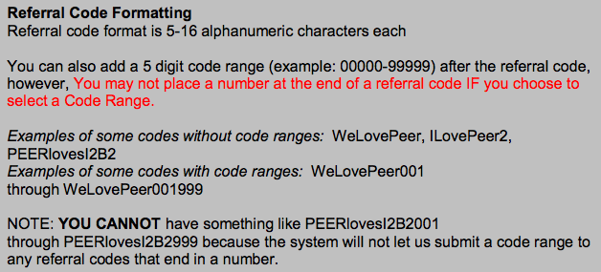

Documenting your conversion of members
- Use referral codes that allow you to identify members from nonmembers.
  - You will be able to obtain data from the PEER system on the number of surveys completed by referral code.
- Use Twibbons so that you can see how many people are posting that they did the survey

Messaging
Use different types of messaging to involve participants. We also want to share information between us about what messaging works well. If one form of messaging is not working for your group but is working for others, try having a different representative write the messages, your community may respond better to a different voice.

Tips:
Your messaging should focus on “why” people should be involved, rather that “what.”

Whenever possible, include a photo of, or an endorsement from, one of your organization leaders that members will recognize and trust.

Messages to avoid:
- Anything that is not participant-centered. Appeal to them on a personal level.
- Too many acronyms or jargon within a message
- Negative messaging
- Long messages

Example:
Not very appealing: XYZ Organization now has a new patient registry to collect health data with an emphasis on (technical medical jargon).

Better: What is living with (your condition) like for you? Take the survey in the XYZ registry to let your voice be heard to foster new research for better treatments to improve your life.

Message themes:

Measure which messages are resonating with your members by keeping track of how many surveys were completed after you sent out a particular message. We have developed a tracking sheet for this. By tracking your success with themes, you can instantly see what is motivating your members.

Participant/ Patient stories as part of your messaging
Participant or patient stories are extremely compelling. If you do not already have some, make a list of themes you want to have in your messaging for your project. For example, the positive impact that research has had already on individuals, why people might want to share their information, the day the person was diagnosed and what was known about the cause/ condition at that point. Post these stories on your blog if you have one or if they are videos, put them on YouTube. Use the links to the stories in your appeals to others to take the survey.
- Example: “Carol reflects on how past research on xyz condition changed her life and her optimism about xyz Patient Registry’s ability to accelerate research.”

Overcoming barriers
Some people can struggle with technology or may have questions while they are completing the survey. Develop ways to answer their questions such as:
- Skype sessions
- Training and utilizing navigators
- Appointing point people within your organization who are available by phone on certain days/times to answer questions
- Inviting members to email their questions and answering all questions received in an FAQ on your website, Facebook or any means that your members use regularly
- Webinars to explain and answer questions (create a presentation for this purpose).
- Conference calls to answer questions (document questions and answers and put them on your site in the form of an FAQ)
- Encouraging members who have these issues to invite a friend or family member to help them to fill out the survey
- Encouraging members to connect with other members through your Facebook group or other social media, and ask them about their experience with the survey
- In your survey, include a short question about users’ experience, and include these responses on your website. Address negative responses and give future users advice on how to avoid things that confused previous survey takers.

Anticipate “trust issues”

Some members of other groups have expressed having trust issues about reporting their information. You may need to craft some messages about why people can trust this project. This shouldn’t be your primary messaging but you can sprinkle it in to help the naysayers to move forward. You can also invite them to a webinar, tweetchat or Facebook discussion about it. Some members may also have trust issues related to sharing information via an Internet portal. You can discuss the privacy settings in PEER and the safety of the portal in discussions, tweetchats, Facebook posts, emails, webinars. It also might be helpful to mention that similar projects have benefitted other communities (i.e. Sickle Cell communities), so that members know projects like this have happened before, which might make them more trusting.

Sample Outreach Plan
Utilizing the ideas above and others that you may think of, your outreach plan will look something like this:
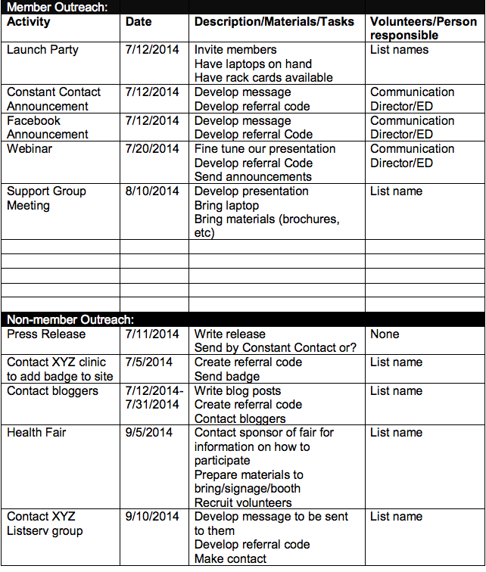

Post-Launch Success:
- Consider
  - What results are you getting?
  - What is working best?
  - What is not working best?
  - Are you tracking?
- Engagement
  - Word Choice: Selective Vocabulary Increases Participation
  - Brand your registry
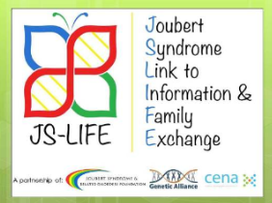
#JSLIFE

  - See the Outreach Documents provided (note: there are pre and post-launch information that must be collected (Table 1.2 and 2.1)

Table 1.2
Population Overview | Population 1
 | Current | Proposed
Enrollment
Number of patients in network
Age
Percent 17 years or younger
Percent 18 to 44 years
Percent 45 to 64 years
Percent 65 years or older
Race/Ethnicity
Percent American Indian/Alaska Native
Percent Asian
Percent Native Hawaiian or other Pacific Islander
Percent black or African American
Percent known Hispanic or Latino ethnicity
Percent white
Percent other or unknown
Member Retention
Percent enrolled at 1 year
Percent enrolled at 3 years
Percent enrolled at 5 years
Note: Numbers outside parentheses are US network numbers; numbers inside parentheses are worldwide network numbers. Proposed percentages for Member Retention are not given as retention refers to the current network only.

Table 2.1
 | Organization
 | Current |  |  | Proposed Addition (in enrollment numbers)
 | Percent of network population | Number of years collected | Percent captured electronically
Data Types
Contact information | A:  C:
Demographic data | A:  C:
Clinical information pertinent to the condition | A:  C:
Biospecimen resources | A:  C:
Patient-generated data | A:  C:
Biophysiological data | A:  C:
Survey data | A:  C:
Clinical trials data | A:  C:
Data Sources
Registry data | A:  C:
EHR/EMR data | A:  C:
Patient portals | A:  C:
View, download, and transmit (VDT) | A:  C:
Online Surveys | A:  C:
Mobile technologies | A:  C:
Other: Physician Referral | A:  C:
Note: Numbers outside parentheses are US network numbers; numbers inside parentheses are worldwide network numbers. A refers to affected individuals in the network; C refers to individuals that are controls/unaffected in the network; unkn abbreviates unknown.

Press Release Template:

4301 Connecticut Avenue NW - Suite 404
Washington DC 20008-2304
Telephone:202.966.5557 x201
FOR IMMEDIATE RELEASE
Fax: 202.966.8553

Contact: Tanya Murza

tmurza@geneticalliance.org

Robert Wood Johnson Foundation Project Launch

WASHINGTON, DC (DATE) (information about the Grantee and Granteur) announced today that the (regsitry’s name) launched today. This registry is a project of the (organization).

Information about the organization and disease/ condition/ disorder:
The Hepatitis Foundation International (HFI) is a 501 (c) 3 non-profit organization established in 1994 with world headquarters located in Silver Spring, MD. Since its inception, HFI has worked on eradicating chronic hepatitis by promoting and advocating for health and wellness. HFI has been on the forefront promoting preventative action to help modify unhealthy liver-damaging behaviors before they start. HFI implements its mission through its touchstones to educate, prevent, serve, support and reach well over 5 million patients and health care professionals annually, through its public and private partnerships. Ninety-two cents of every dollar spent by HFI is dedicated to programs and services.

HFI’s Hepatitis Patient Registry Network (HepPRN) collects self-reported data on the determinants of a patient’s health along the hepatitis health care continuum. This patient-centric survey, focusing on what it’s like to live with hepatitis, is an avenue to engage more individuals in patient centered research.

Quotes:
“Participating in this PEER Platform along with HFI provides you with complete control over what you will share, and what you won’t share” – Ivonne Fuller

“With this registry, there’s now a way to share information with privacy, which gives me a lot of hope for more effective research in the future”- Karen Wirth

Matthew Smith, principal investigator for JS-LIFE (the Joubert Syndrome Link to Information and Family Exchange) said “JS-LIFE is a truly transformative patient-centered registry for those with Joubert syndrome and related disorders. Those with rare conditions don’t always have a strong voice in medical research and advocacy. If those with Joubert syndrome and other rare conditions cannot speak for themselves, then it is our duty at Disease Advocacy Organizations like the Joubert Syndrome & Related Disorders Foundation to advocate boldly for them. CENA and JS-LIFE do just that, allowing the voices of those with Joubert syndrome and other related conditions to be heard: loud and clear. THEY control their own data, THEY are empowered, and THEY are given the voice that they deserve in rare disease advocacy and research. The ultimate goal of JS-LIFE is to improve the lives of those with JS&RD by providing more appropriate means of information sharing and facilitating reciprocal medical research and care they greatly desire."

Information about PEER:
The registry platform is unique. Built on the Platform for Engaging Everyone ResponsiblyTM (PEER), each individual determines his or her own personal data sharing, privacy and access preferences. Private AccessTM designed this contextual granular preference setting system. In addition, as individuals enter health information they see real time comparisons in this gamified system, thanks to technology by TraitwiseTM. PEER and each specific registry have institutional review board approvals.

Each community or organization customizes PEER for their own use. Rhonda P. Buyers, CEO of the National Gaucher Foundation (NGF) states, “It is important to us that PEER reflects our branding, uses guides from our community, and communicates our vision exactly. The National Gaucher Foundation’s Gaucher Network Registry (GNR) is the first ever participant-powered Gaucher registry, providing those with Gaucher disease the opportunity to structure the record of their own individual disease experiences. It will empower individuals with Gaucher disease and their families with a means for using their health information to become proactive in improving the quality of their lives and instrumental in future research studies in the field.”

Background Information about the Grant:
(The nine organizations involved in the CENA project range from common chronic conditions to genetic and rare disorders. Together they have identified outcomes they hope to achieve. The organizations have built the surveys using common data elements and validated instruments where possible, and are especially interested in the cross condition commonalities. They also worked to integrate the common questions and data model of PCORnet to be research ready in 2015.

“The collaboration among these organizations is remarkable. This cross condition registry requires both general and condition specific elements and these organizations are doing a great job learning together about the rigors of registries and the benefits of being able to study comorbidities, quality of life, and burden of disease together”, explained Sharon Terry, principal investigator of CENA and CEO of Genetic Alliance.

The other seven condition advocacy organizations will all launch in the next month. They are Alström Syndrome International, AXYS (formerly KS&A), Dyskeratosis Congenita Outreach, Hepatitis Foundation International, Inflammatory Breast Cancer Research Foundation, MLD Foundation, National Psoriasis Foundation, and PXE International.)

Social Media:
Like the organization on Facebook: (appropriate URL)
Follow on Twitter: @ (project title)

###
About Genetic Alliance
Genetic Alliance engages individuals, families and communities to transform health. Founded in 1986, it is the world's largest nonprofit health advocacy organization network. Genetic Alliance's network includes more than 1,200 disease-specific advocacy organizations, as well as thousands of universities, private companies, government agencies, and public policy organizations. For more information about Genetic Alliance, visit www.geneticalliance.org.

The Partners

About Private Access
Private Access is striving to make it safe for sensitive personal information such as medical records and genomic data to be accessible over the Internet. Through PrivacyLayer®, the firm ’s core services platform, Private Access empowers individuals to set granular privacy preferences and use dynamic consent tools to address a number of critical privacy concerns and related hurdles that have traditionally impeded privacy-protective sharing of this valuable information. In 2009, Forbes named Private Access as #12 on its list of America’s Most Promising Companies. More information is available at www.privateaccess.com.

About UC San Francisco (UCSF)
UCSF is a leading university dedicated to promoting health worldwide through advanced biomedical research, graduate-level education in the life sciences and health professions, and excellence in patient care. It includes top-ranked graduate schools of dentistry, medicine, nursing and pharmacy, a graduate division with nationally renowned programs in basic biomedical, translational and population sciences, as well as a preeminent biomedical research enterprise and two top-ranked hospitals, UCSF Medical Center and UCSF Benioff Children’s Hospital. More information is available at www.ucsf.edu.

About UC Davis Health System
UC Davis Health System improves lives by providing excellent patient care, conducting groundbreaking research, fostering innovative, interprofessional education and creating dynamic, productive community partnerships. It encompasses one of the country's best medical schools, a 619-bed acute-care teaching hospital, a 1,000-member physician practice group and the Betty Irene Moore School of Nursing. Together, they make UC Davis a hub of innovation that is transforming health for all. For information, visit www.healthsystem.ucdavis.edu.

Appendix: Example of Badges on Site

